Military Institute of Science and Technology

Department of Computer Science and Engineering

Course Title: Data and Tele-Communication Sessional

Course Code: CSE-318, Cr. Hr: 1.50

Level-3, Term-2

# Experiment No: 13

**Name of the experiment: DSB-SC and SSB Demodulators.**

1. **Objectives:**
   1. To understand the operation theory of double sideband suppressed carrier (DSB-SC) demodulator and single sideband (SSB) demodulator.
   2. To design and implement the DSB-SC and SSB demodulators.
   3. To measure and adjust the DSB-SC and SSB demodulators.
2. **Theory**:

**The Operation Theory of DSB-SC and SSB Demodulator:**

When the modulated signal is recovered to the original audio signal, the procedure is known as demodulation. In this chapter, we will discuss the operation theory of DSB – SC and SSB demodulator.

Assume that a DSB – SC signal is , where m(t) represents the audio signal or the low frequency signal. If this signal is multiplied by , then we get



=  .................................................... 6-1

= 

By using Fourier Transform on equation (6-1), we can rewrite the expression as



.................. 6-2

=

When  pass though a low-pass filter, which its frequency bandwidth equals or greater than the frequency bandwidth of m(t), but smaller than then the only term left in equation (6-2) is



 ....................................... 6-3

By using Fourier Transform on equation , we get

 ................................................... 6-4

From equations, we know that the synchronous demodulator in figure can recover the m(t) signal from the DSB – SC signal.

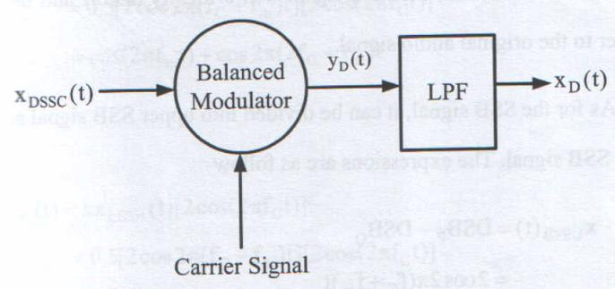

Figure 6-1 Block diagram of synchronous demodulator.

On the other hand, we consider the demodulator 0(t) between the carrier signals of the demodulator and modulator, then this situation will cause the signal distortion and the demodulator is unable to recover the original audio signal.



= ................................................... (6-5)

= 

When pass through a low-pass filter, which its frequency bandwidth equals or greater than the frequency bandwidth of m(t), but smaller than then we get

 ............................................................ (6-6)

In equation if the phase difference  is a constant, then it will cause attenuation on the amplitude. However, if the phase difference  is a time domain function, then the signal will critically distort and unable to recover to the original audio signal.

As for the SSB signal, it can be divided into upper SSB signal and lower SSB signal. The expressions are as follow



= ............................................................ 6-7

or



= .................................................. 6-8

where,





frequency of carrier signal.

frequency of audio signal.

k : gain of the multiplier of mixer.

If equations (6-7) and (6-8) is multiplied , then we get



 ................................................ 6-9



or



 ................................................ 6-10



When  or  pass through a low pass filter, which its frequency bandwidth equals or greater than the frequency bandwidth of *m(t),* but smaller than , then we get

 .......................................................... (6-11)

From equations (6-7) to (6-11), we know that the synchronous demodulator in figure 6-2 can recover the *m(t)* signal from the SSB signal.

On the other hand, if we consider the phase difference between the carrier signals of the demodulator and modulator, then this situation will cause the signal distortion and the demodulator is unable to recover the original audio signal.

 .......................... 6-12

or

 ....................... 6-13

Therefore, when  pass through the low-pass filter, then we get

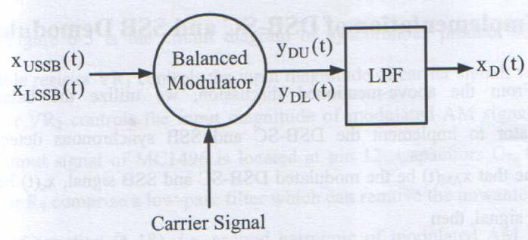

Figure 6-2 Block diagram of synchronous demodulator.

 ............................ 6-14

Or when  pass through the low pass filter, then we get

 ....................... 6-15

From equations 6-14 and 6-15, we know that if the phase difference between the carrier signals of the demodulator and modulator equals to each other, then . This situation indicates that the audio signal can be recovered. If the phase difference is not zero, then we noticed that the demodulated signal will distort and unable to recover to the original audio signal.

**6-2 Implementation of DSB-SC and SBSC Demodulator:**

From the above mention discussion, we utilize the balanced modulator to implement the DSB-SC and SSB synchronous detectors, Assume that  be the modulated DSB-SC and SSB signal,  be the carrier signal, then

 ............................... 6-16

 ...................................................... 6-17

When these two signal input into two differential ports of balanced modulator, then the output signal of the balanced modulator is as follow



.............. .... 6-18

Where *k* represents the gain of the balanced modulator. The first term is the DC signal, second term is the audio signal and third term is the second harmonic of modulated AM signal. If we can take out the second term from , then we can obtain the exact demodulated DSB-SC and SSB signals or audio signal.

Figure 6-3 is the circuit diagram of synchronous product detector. Variable resistor VR1 controls the input magnitude of carrier signal; variable resistor VR2 controls the input magnitude of modulated AM signal; then the output signal of MC1496 is located at pin 12. Capacitors C7, C9 and resistor R9 comprise a low pass filter which can remove the unwanted third term of equation 6-18, i.e. second harmonic of modulated AM signal. Since the active low pass filter provides gain, so, the objective of the low pass filter is to prevent attenuation on the output signal due to the RC circuit. The DC signal, which is the first term of equation 6-18, can be blocked by C10. Therefore the signal that we obtain at output port will be

 ................................................... 6-19

Equation 6-19 represents the audio signal or in others words the original modulated AM signal can be taken out via product detector.

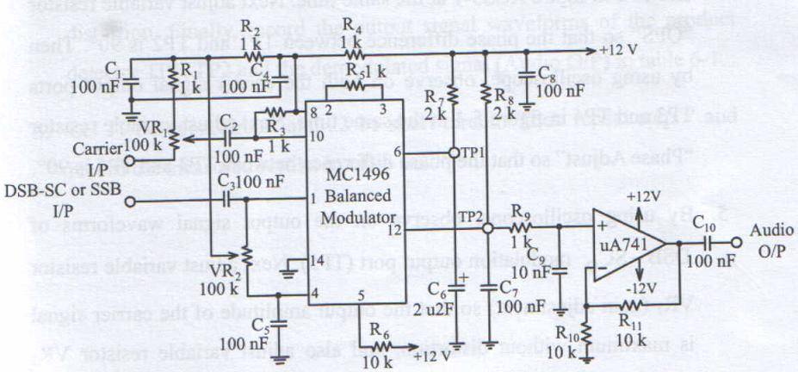

Figure 6-3 Circuit diagram of synchronous product detector.

**3. Equipments Needed**

1. ETEK ACS-3000-03 module
2. Signal source (Function generator)
3. Oscilloscope

**4. Procedure DSB-SC Demodulator:**

1. To implement a DSB-SC modulator as shown in figure 5-5 or refer to figure ACS5-1on ETEK ACS-3000-03 module to produce the modulated DSB-SC signal source.
2. To implement a product detector of DSB-SC demodulator as shown in figure 6-3 or refer to figure ACS6-1 on ETEK ACS-3000-03 module. Then let J1 be short circuit and J2 be open circuit.
3. At the audio signal input port (Audio I/P) in figure ACS5-1, input a 300 mV amplitude and 1KHz sine wave frequency. Then at the carrier signal input port (Carrier I/P) in figure ACS5-1, input a 300mV amplitude and 200 KHz sine wave frequency.
4. By using oscilloscope, observe on the both the audio signal output ports TP1 and TP2 in figure ACS5-1 at the same time. Next adjust variable resistor “QPS” so that the phase difference between TP1 and TP2 is 900. Then by using oscilloscope, observe on both the carrier signal output ports TP3 and TP4 in figure 5-1 at the same time. Next adjust variable resistor “Phase adjust” so that the phase difference between TP3 and TP4 is 900.
5. By using oscilloscope, observe on the output signal waveforms of DSB-SCQ modulation output port (TP5). Next adjust variable resistor VR1 (gain adjustment) so that the output amplitude of the carrier signal is maximum without distortion, and also adjust variable resistor VR3 (modulation index adjustment) so that the canter level of upper peak and lower peak are 0V or the modulation index is 100%. By using oscilloscope again, observe on the output signal waveforms of DSB-SC1 modulation output port (TP6). Next adjust variable resistor VR2 (gain adjustment) so that the output amplitude of the carrier signal is maximum without distortion, and also adjust variable resistor VR4 (modulation index adjustment) so that the center level of upper peak and lower peak are 0V or the modulation index is 100%.
6. Connect the modulated DSB-SC1 signal (DSB-SC1 O/P) in figure ACS5 – 1to the input terminal (DSB-SC/SSB I/P) of the product detector in figure ACS6-1. At the same time, input the same carrier signal in figure ACS5-1 to the carrier signal input port (Carrier I/P) in figure ACS6-1.
7. By using oscilloscope, observe on the output signal waveforms of the product detector (Audio O/P) in figure ACS6-1. Next adjust variable resistors VR1 and VR2, so that the output amplitude is maximum without distortion. Finally, record the output signal waveforms of the product detector TP1, TP2 and the demodulated signal (Audio O/P) in table 6-1.
8. Let J1 be open circuit and J2 be short circuit. Then repeat step 7 and record the measured results in table 6-2.

Table 6-1 Measured results of DSB-SC demodulator.

(J1 be short circuit, J2 be open circuit)

|  |  |
| --- | --- |
| TP1 |  |
| TP2 |  |
| Audio  O/P |  |

Table 6-2 Measured results of DSB-SC demodulator.

(J1 be open circuit, J2 be short circuit)

|  |  |
| --- | --- |
| TP1 |  |
| TP2 |  |
| Audio  O/P |  |

**5. Procedure SSB Demodulator**

1. To implement a SSB modulator as shown in figure 5-6 or refer to figure ACS5-1 on ETEK ACS-3000-03 module to produce the modulated SSB signal source.
2. To implement a product detector of SSB demodulator as shown in figure 6-3 or refer to figure ACS6-1 on ETEK ACS-3000-03 module. Then let J1 be short circuit and J2 be open circuit.
3. At the audio signal input port (Audio I/P) in figure ACS5-1, input a 300 mV amplitude and 2 KHz sine wave frequency. Then at the carrier signal input port (Carrier I/P) in figure ACS5-1, input a 300 mV amplitude and 200 KHz sine wave frequency.
4. By using oscilloscope, observe on both the audio signal output ports TP1 and TP2 in figure ACS5-1 at the same time. Next adjust variable resistor “QPS” so that the phase difference between TP1 and TP2 is 900. Then by using oscilloscope, observe on both the carrier signal output ports TP3 and TP4 in figure 5-1 at the same time. Next adjust variable resistor “Phase adjust” so that the phase difference between TP3 and TP4 is 900.
5. By using oscilloscope, observe on the output signal wave forms of DSB-SCQ modulation output port (TP5). Next adjust variable resistor VR1 (Gain adjustment) so that the output amplitude of the carrier signal is maximum without distortion, and also adjust variable resistor VR3 (modulation index adjustment) so that the center level of upper peak and lower peak are 0 V or the modulation index is100%. By using oscilloscope again, observe on the output signal wave forms of DSB-SC1 modulation output port (TP6). Next adjust variable resistor VR2 (gain adjustment) so that the output amplitude of the carrier signal is maximum without distortion, and also adjust variable resistor VR4 (modulation index adjustment) so that the center level of upper peak and lower peak are 0 V or the modulation index is 100%.
6. Connect the modulated SSB Signal (SSB O/P) in figure ACS5-1 to the input terminal (DSB-SC/SSB I/P) of the product detector in figure ACS6-1. At the same time input the same carrier signal in figure ACS5-1 to the carrier signal input port (carrier I/P) in figureACS6-1.
7. By using oscilloscope, observe on the output signal waveforms of the product detector (Audio O/P) in figure ACS6-1. Next adjust variable resistors VR1 and VR2, so that the output amplitude is maximum amplitude is maximum without distortion. Finally, record the output signal waveforms of the product detector TP1, TP2 and the de4modulated signal (Audio O/P) in table 6-3.
8. Let J1 be open circuit and J2 be short circuit. Then repeat step 7 and record the measured the measured results in table 6-4.

Table 6-3 Measured results of SSB demodulator.

(J1 be short circuit, J2 be open circuit)

|  |  |
| --- | --- |
| TP1 |  |
| TP2 |  |
| Audio  O/P |  |

Table 6-4 Measured results of SSB demodulator.

(J1 be open circuit, J2 be short circuit)

|  |  |
| --- | --- |
| TP1 |  |
| TP2 |  |
| Audio  O/P |  |

**6. Problem Discussion:**

1. Explain the demodulation of the DSB-SC and SSB signals.
2. If the phase difference of the carrier signal in the synchronized demodulator and the carrier signal in the modulator is different, then explain what will the results be.

Explain the functions of low-pass filter in the synchronized demodulator. And also explain what will the output waveform be, if the low-pass filter is neglected.